“Local Area Network Design”
A Research Presented in Partial Fulfillment of the Requirements for
COEPRO14 (Data Communication)

Submitted By:
Belardo, John Carlo B.
Canatoy, Ara Jean C.
Donguines, Eugene
Espero, Lexter B.
Ladrera, Jose Mariano L.
Lebuna, Angelo Daniel A.
Mercurio, Mayette V.
Ondes, John LLoyd L.
Ortiz, Oddessa Claire B.

Bachelor of Science in Computer Engineering
Submitted to the College of Engineering and Digital Technology Department of Computer Engineering
2025-2026
CHAPTER III: Cabling Installation
3.0 Room Cabling Assignment
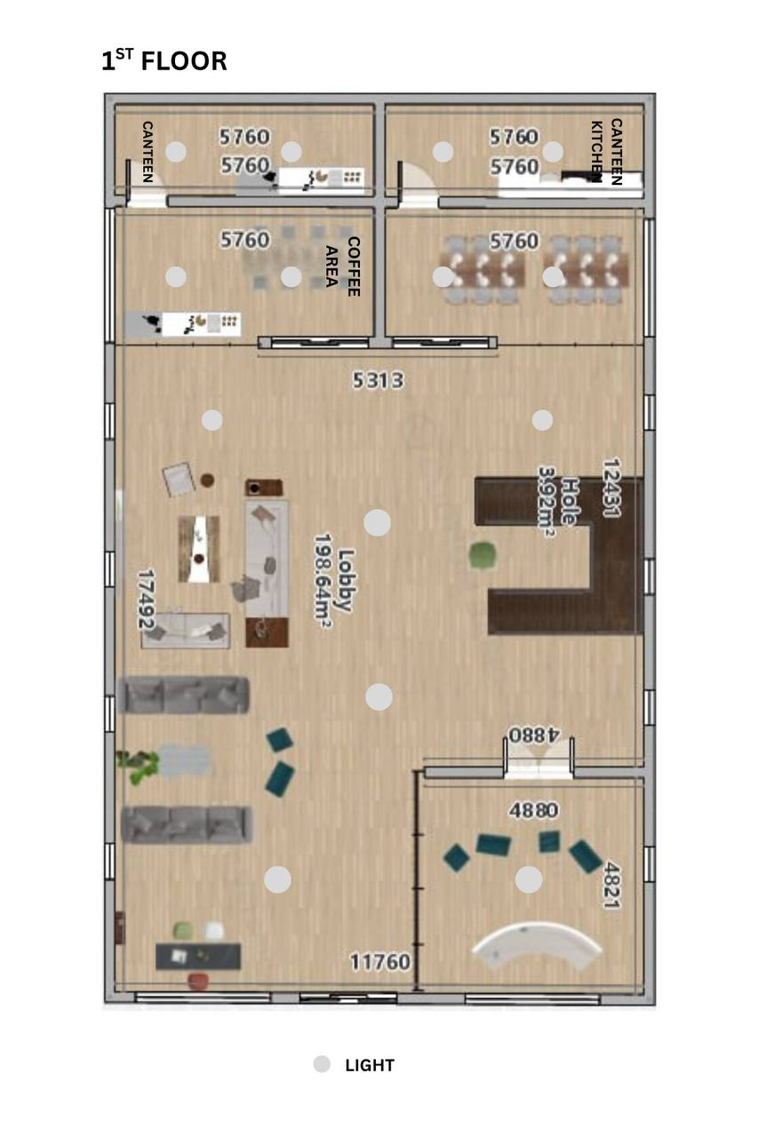
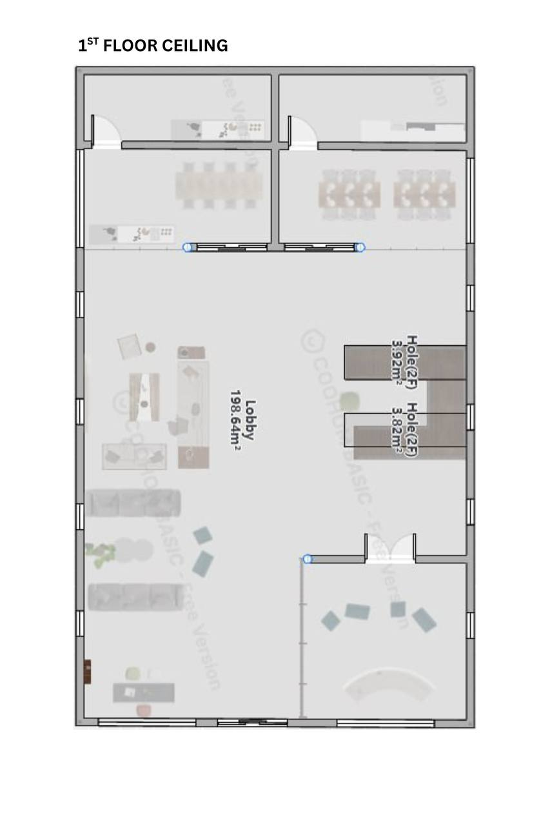
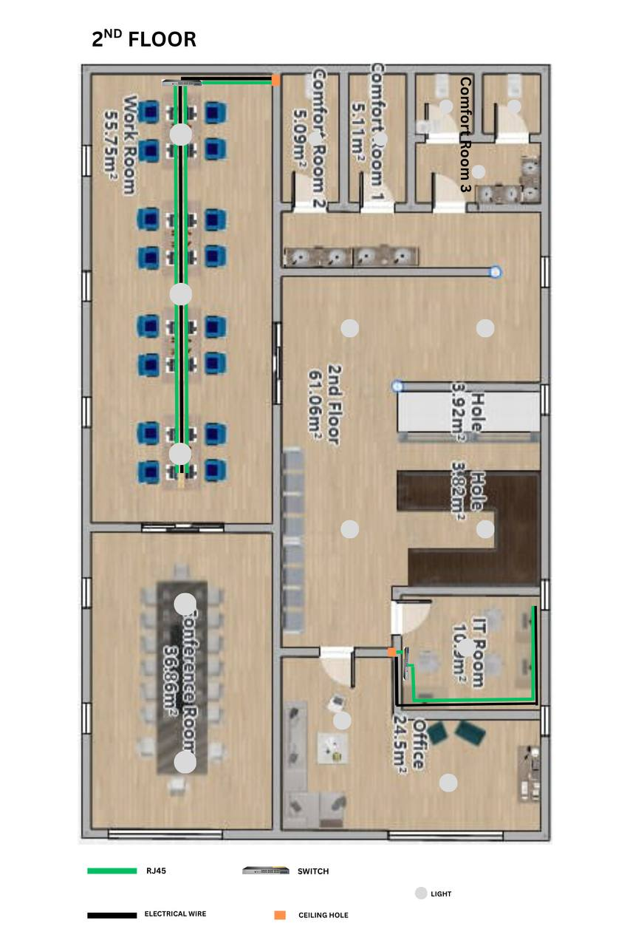
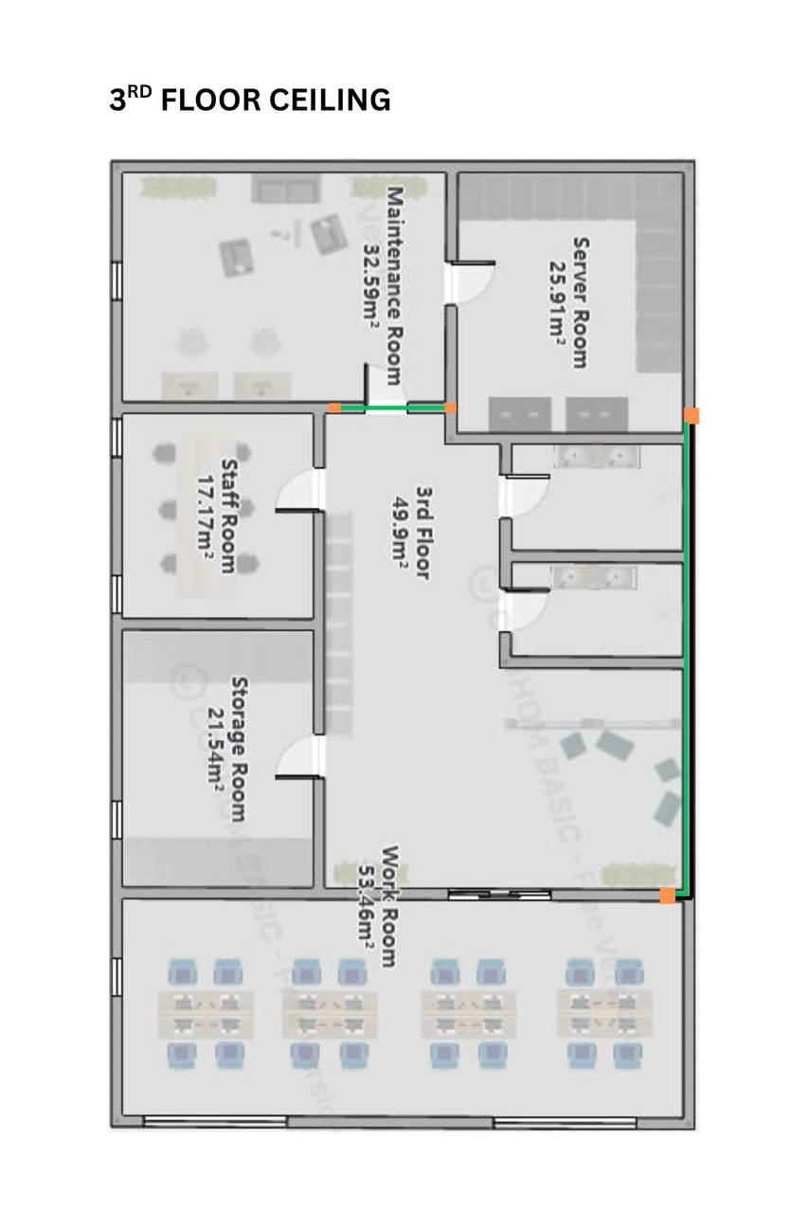
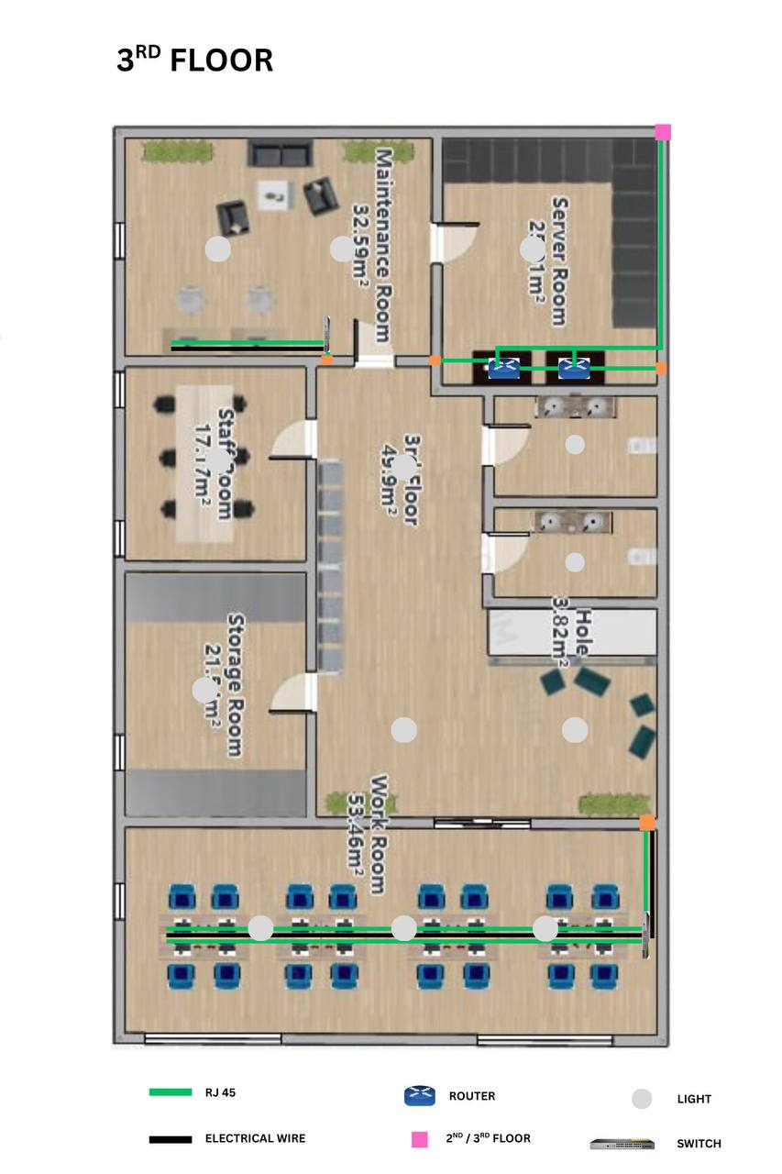
CHAPTER IV: Design Configuration
4.0 SERVER IP ADDRESS CONFIGURATION
In this chapter we will configure the IP address of the network for Static IP’s and DHCP.
STATIC IP CONFIGURATION ( GUI):
Step 1: On the task bar, click Start the go to Settings.

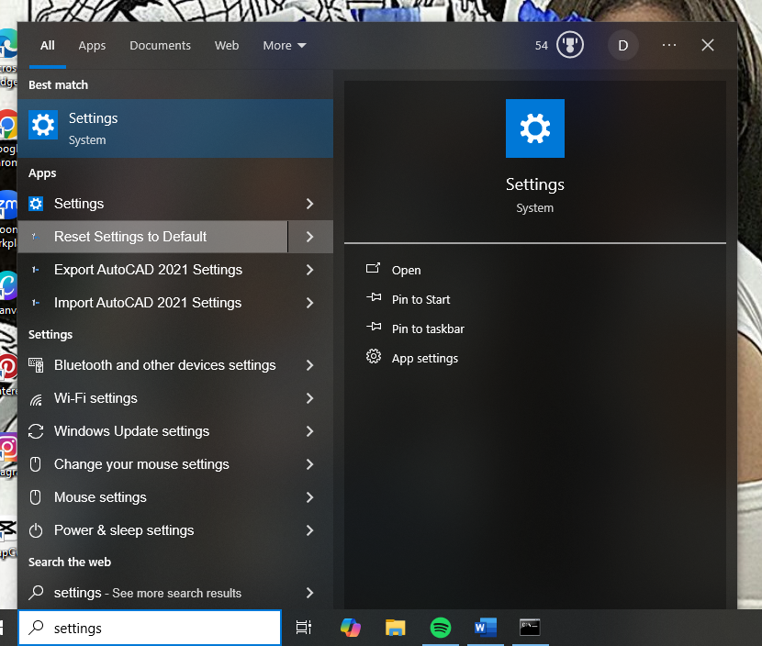

Step 2: Click Network & Internet.

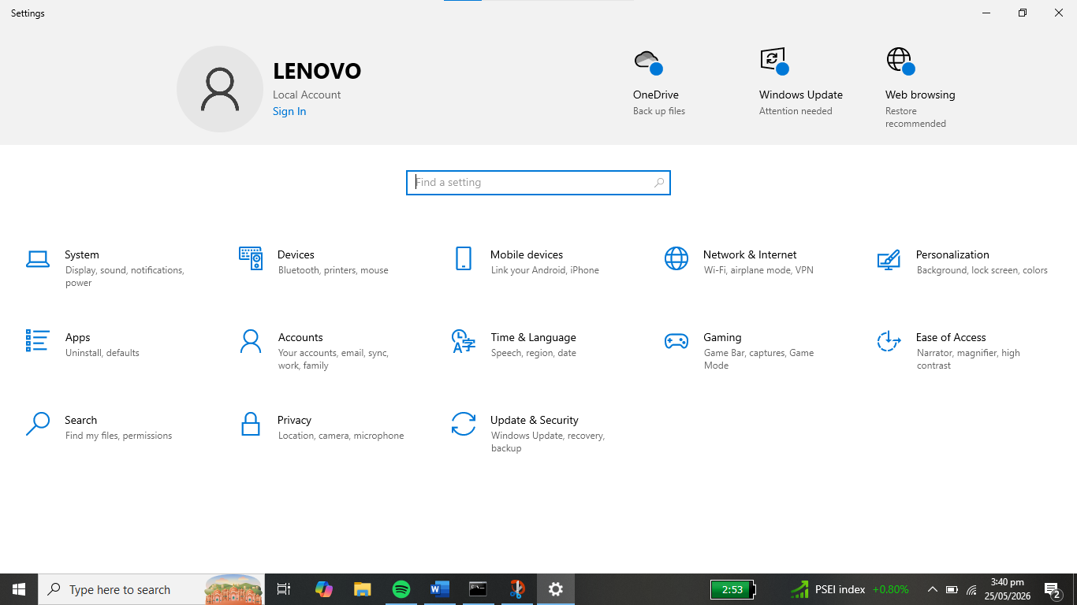

Step 3: Select Wi-Fi

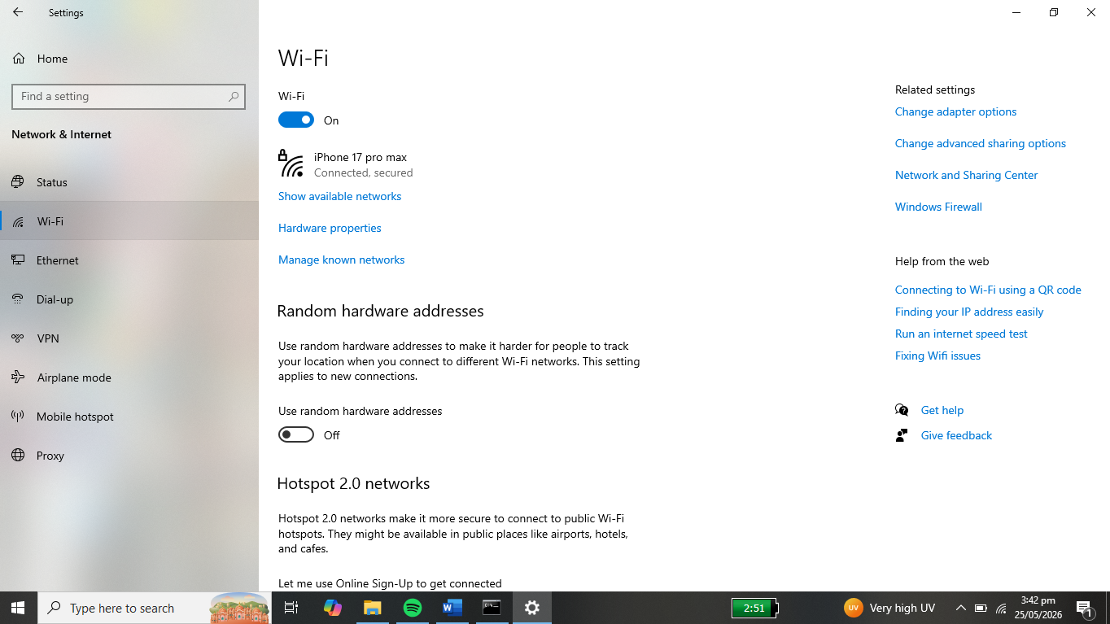

Step 4: Click the connected network.

Step 5: Go to IP Settings and click the Edit button.

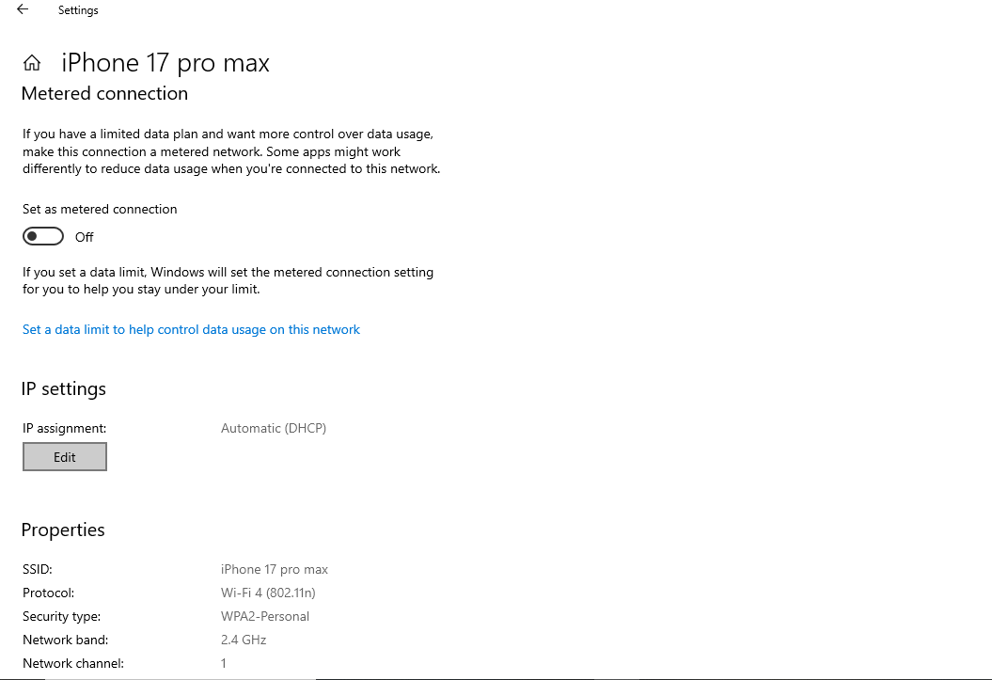

Step 6: In the Edit IP Settings, change from Automatic (DHCP) to Manual.

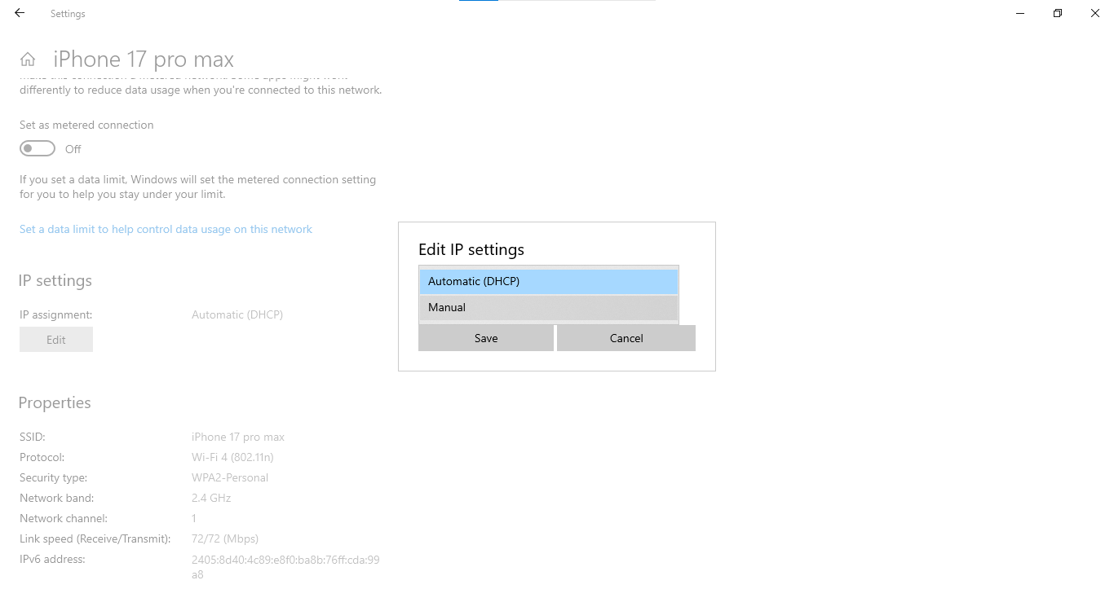

Step 7: Select the IPV4 and configure the other requirements then click Save.

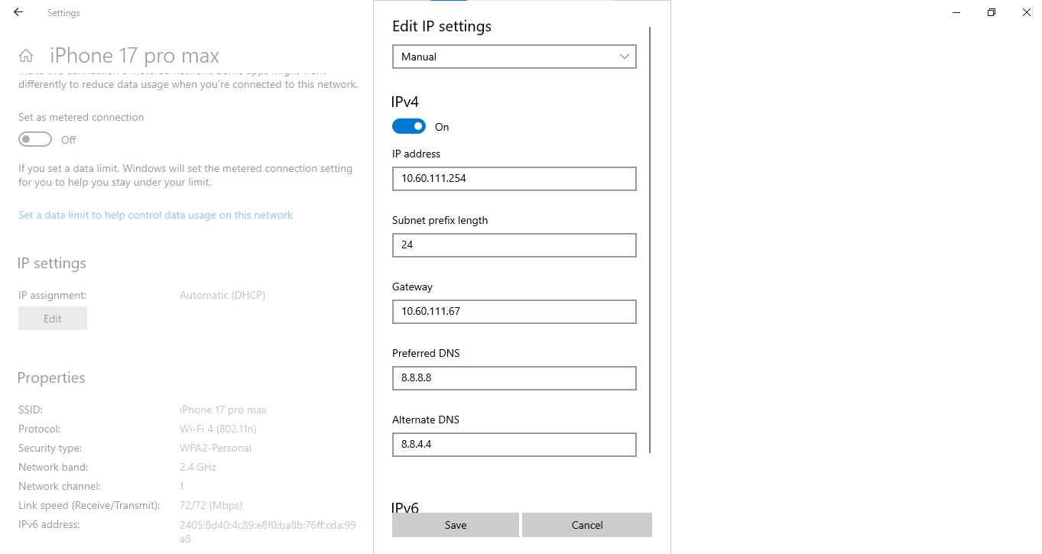
(Actual values are depends on the user’s network configuration)

Step 8: Click Save button to apply the changes.

(All the the information above is just an example, it depends on the network set-up)

B. STATIC IP CONFIGURATION (CLI):
Command Prompt

Step 1: On the task bar, Search the Command Prompt and press Enter.

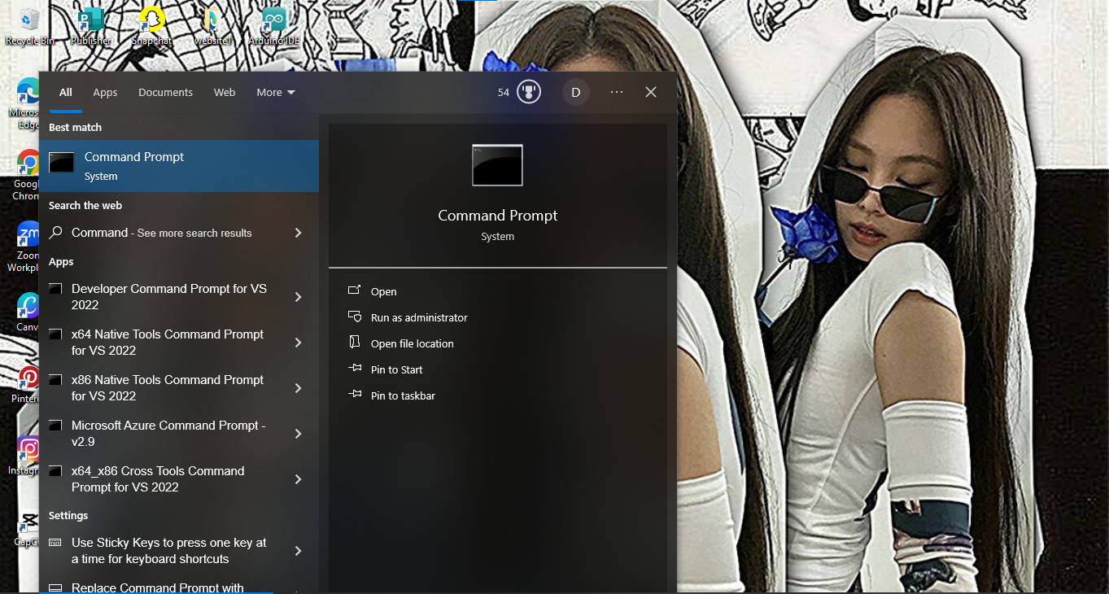

Step 2: In the search option of Command Prompt, Click the Run Administrator.

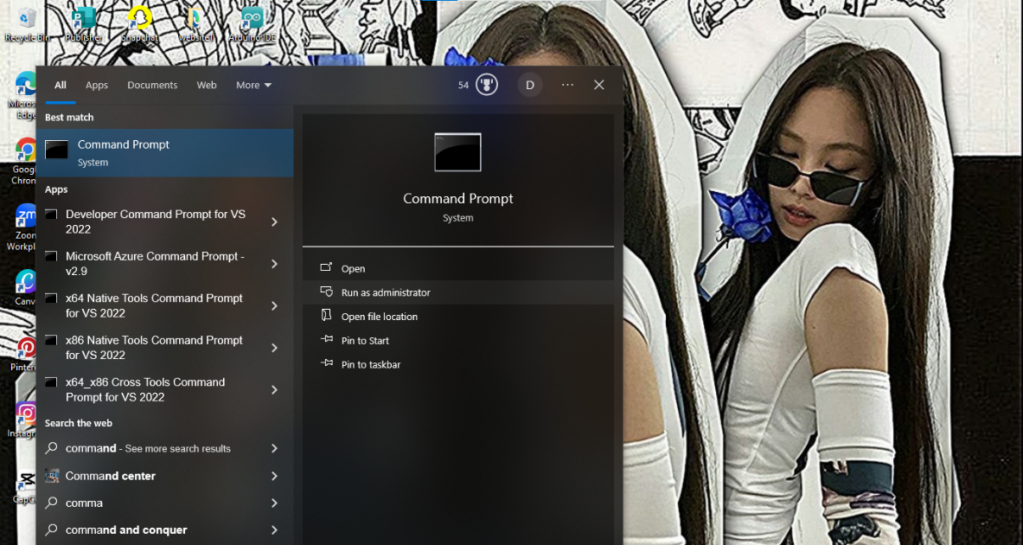

Step 3. In the Run Administrator (Command Prompt), type the “ipconfig/all” and Enter.

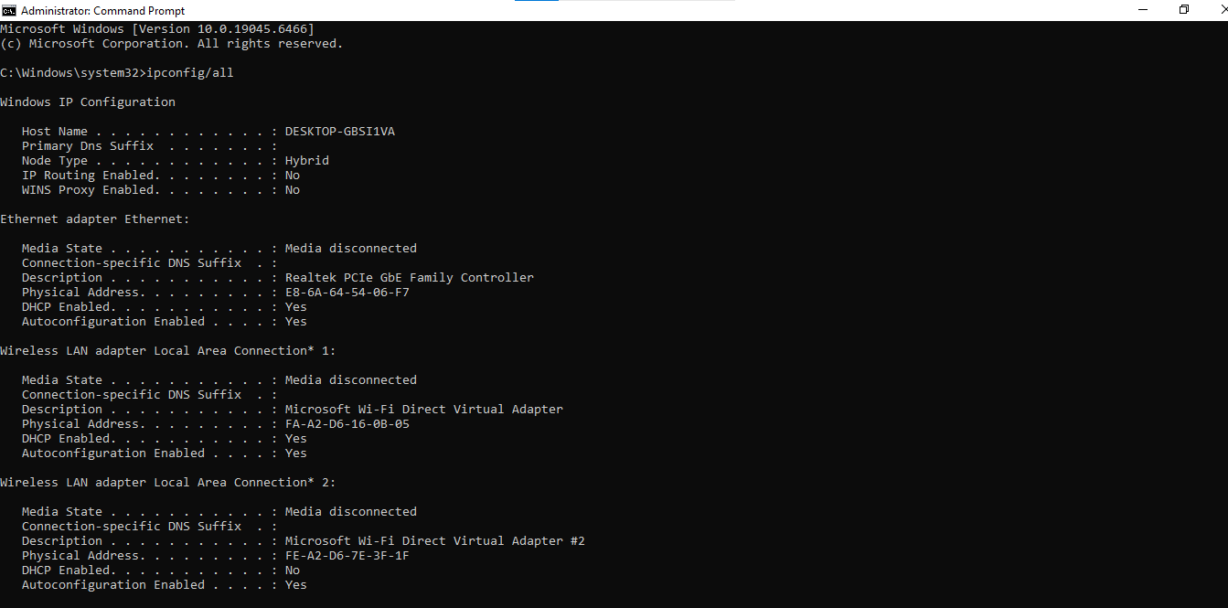

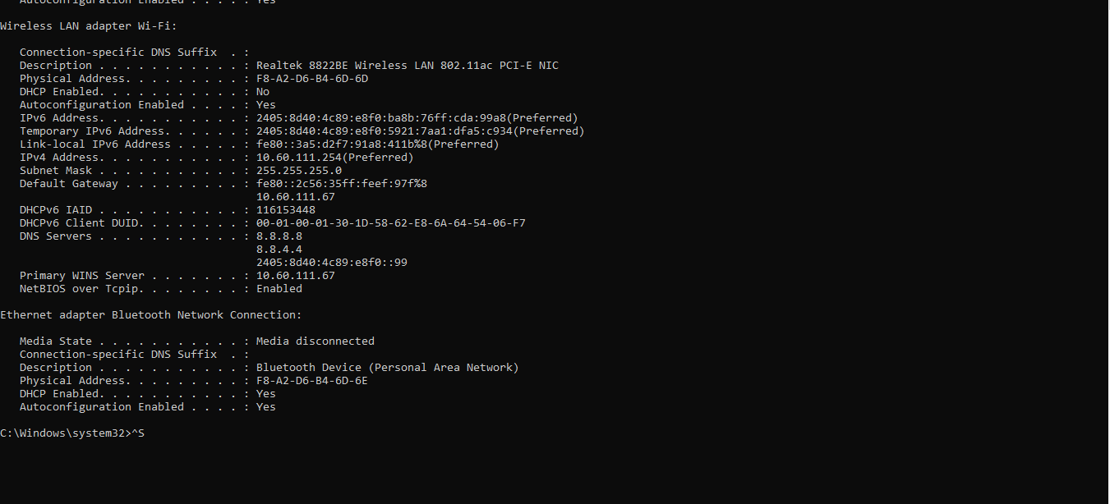

Step 4: Type the information and press Enter.

“netsh interface ip set address name=”Wi-Fi” static 10.60.111.254 255.255.255.0 10.60.111.67”. Those information enables you to assign and configure the static IP Address.

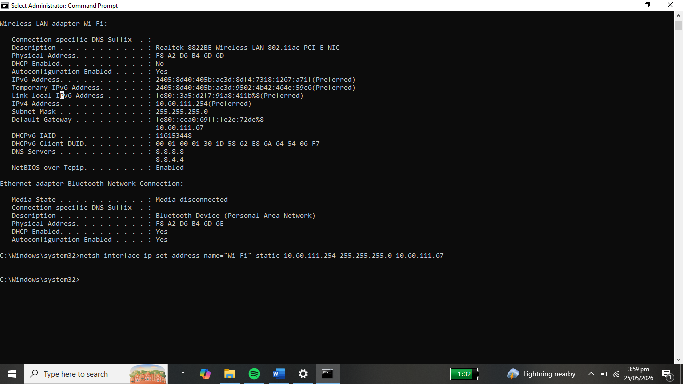

Step 5: Type this command to set up the DNS server address
“netsh interface ip set address name=”Wi-Fi” static 8.8.8.8”
“netsh interface ip set address name=”Wi-Fi” 8.8.4.4”

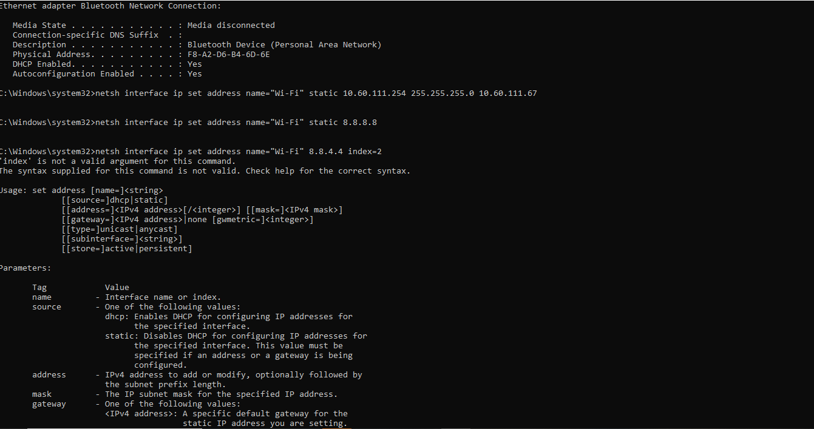

C. DYNAMIC IP CONFIGURATION (GUI)
Control Panel

Step 1: On the task bar, click Start and search Control Panel.
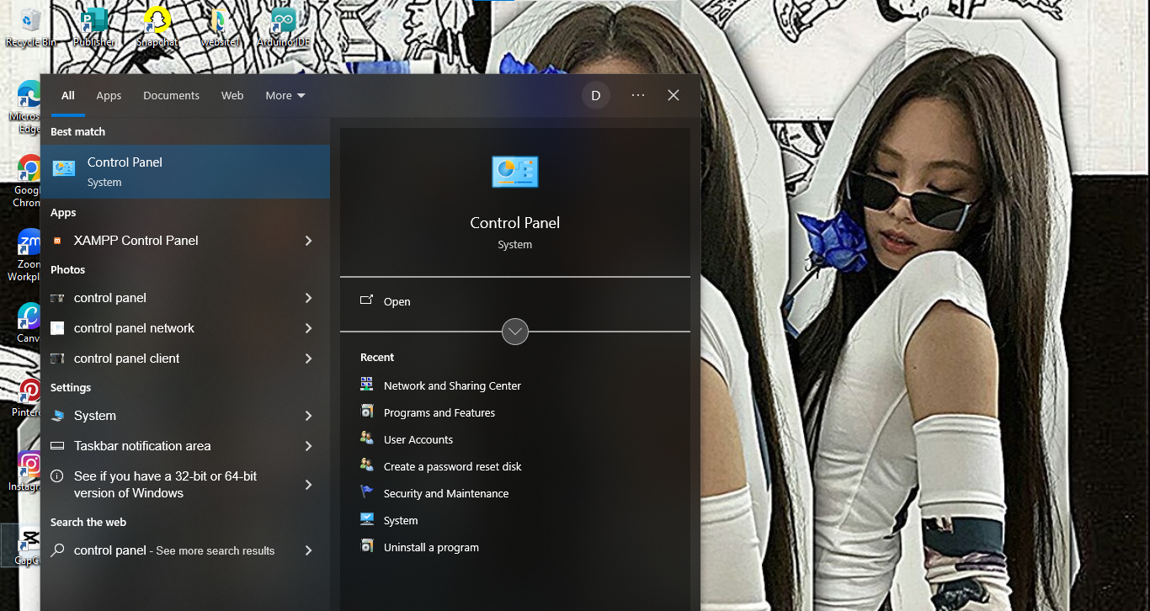

Step 2: Click the Network & Internet

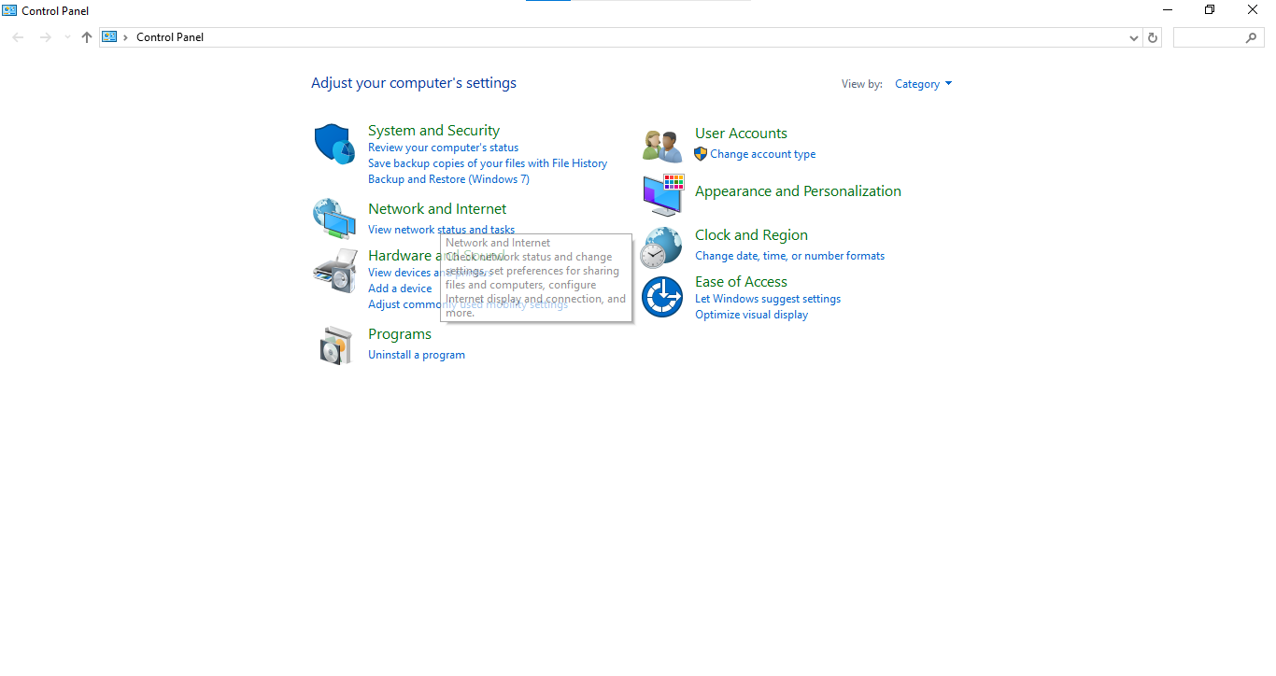

Step 3: Select the Network and Sharing Center

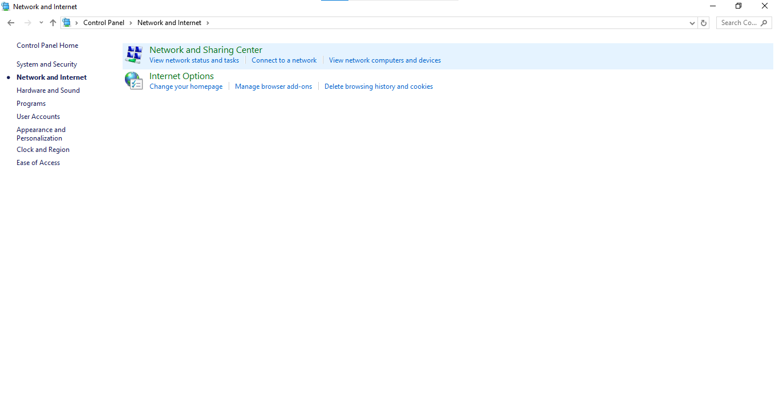

Step 4: Select the Change adapter settings.

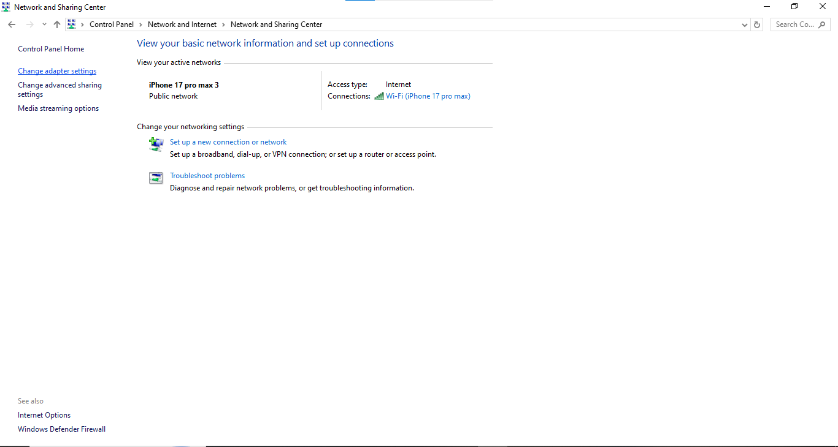

Step 5: Locate your Wi-Fi and right click and select Properties.

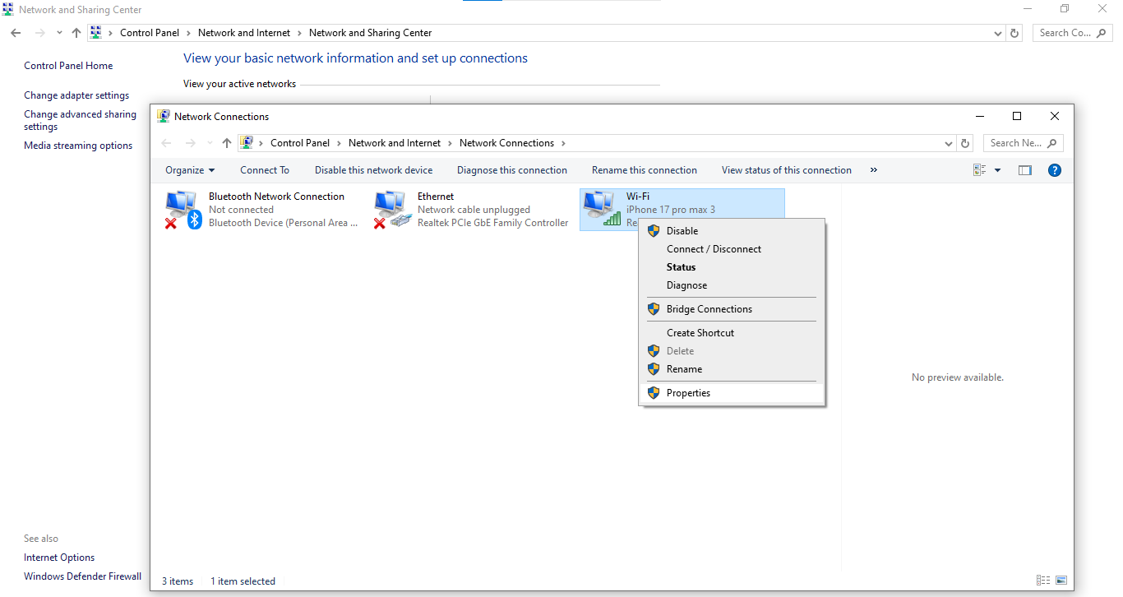

Step 6:In the Properties window, select the Internet Protocol Version (TCP/IPv4) and click the Properties.

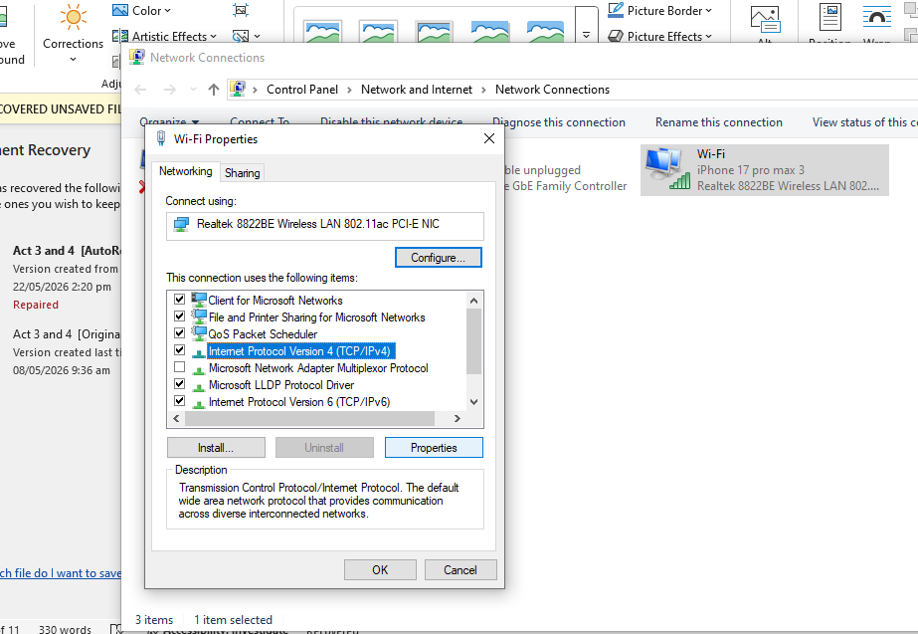

Step 7: In the TCP/IPv4 Properties, select the “Obtain an IP address automatically” and “Obtain DNS server address automatically” then, press Ok.

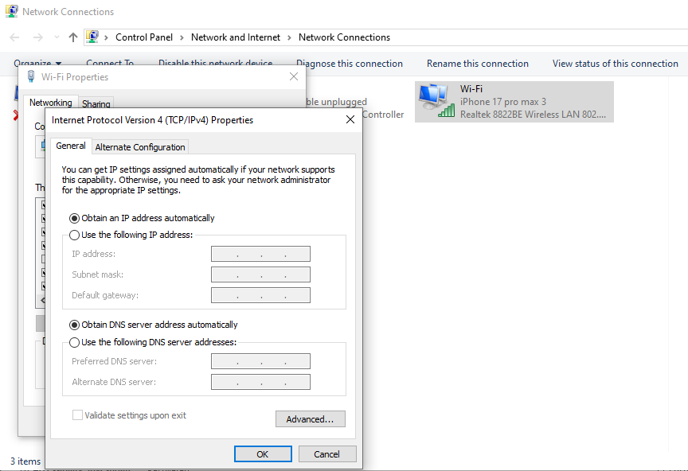

D. DYNAMIC IP CONFIGURATION (CLI)
Command Prompt

Step 1: On the task bar, search the Command Prompt

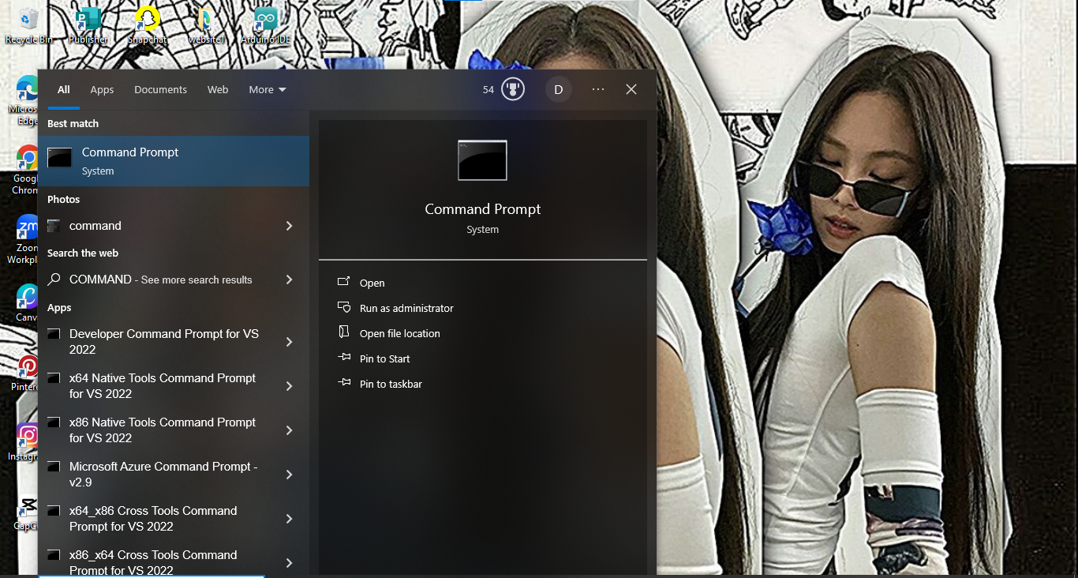

Step 2: Select the Run Administrator

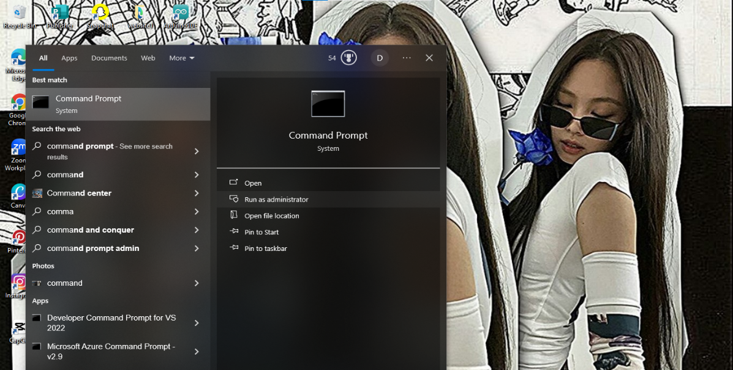
Step 3: Type the command ipconfig and Enter.
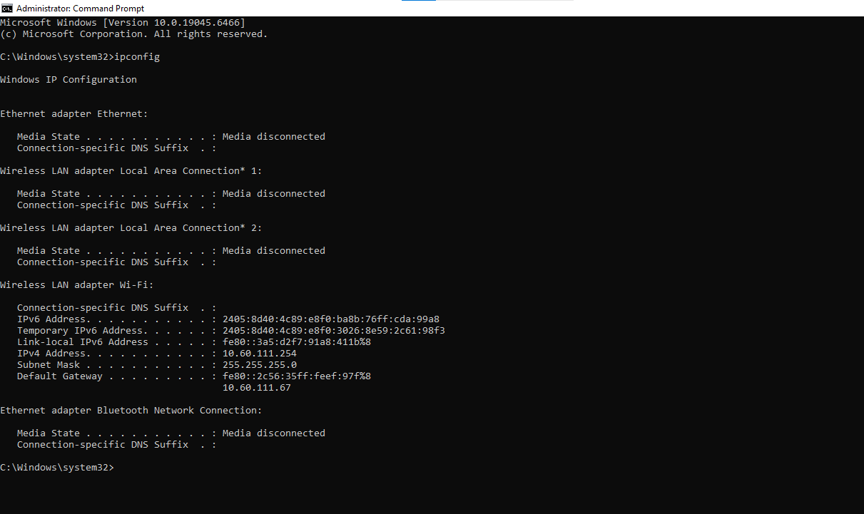

Step 4: Type the command:
Netsh interface set ip address name=”Wi-Fi” dhcp

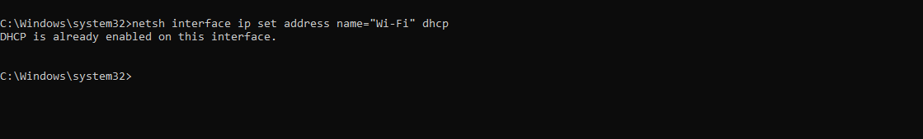

VERIFICATION

Step 1: Type the command:
Ipconfig/all

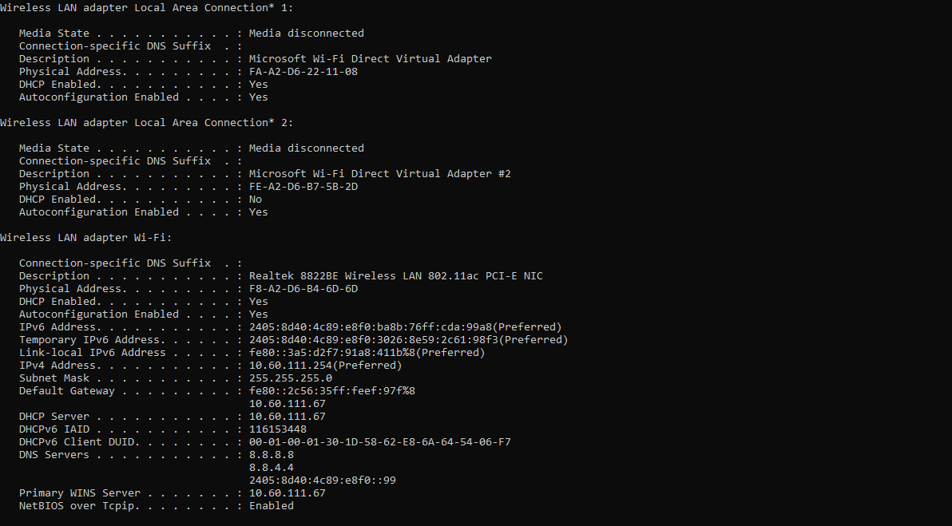

Step 2: Test gateway:
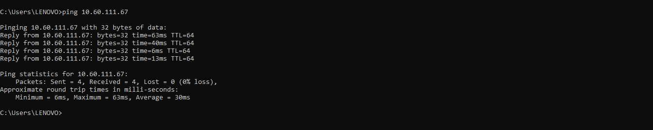

4.1 CLIENT PC CONFIGURATION (DHCP)
Control Panel

Step 1: On the task bar, search the Control Panel.

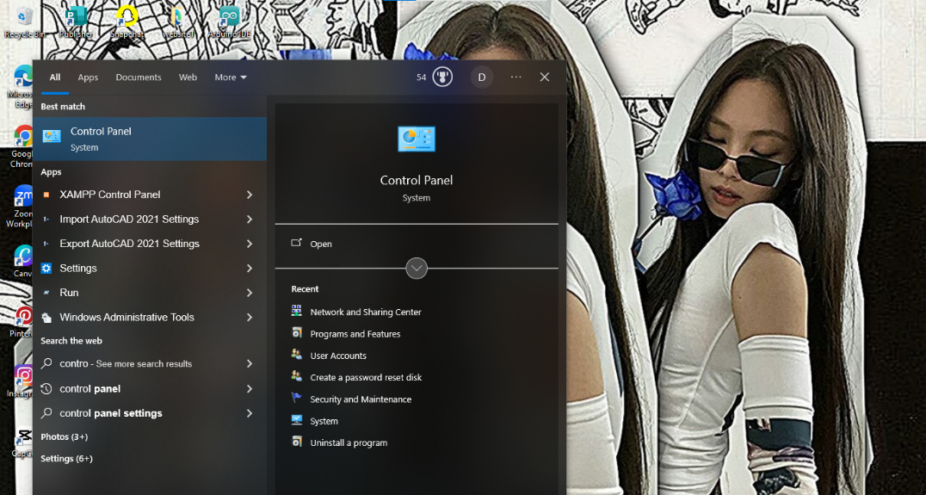

Step 2: Select the Network and Internet

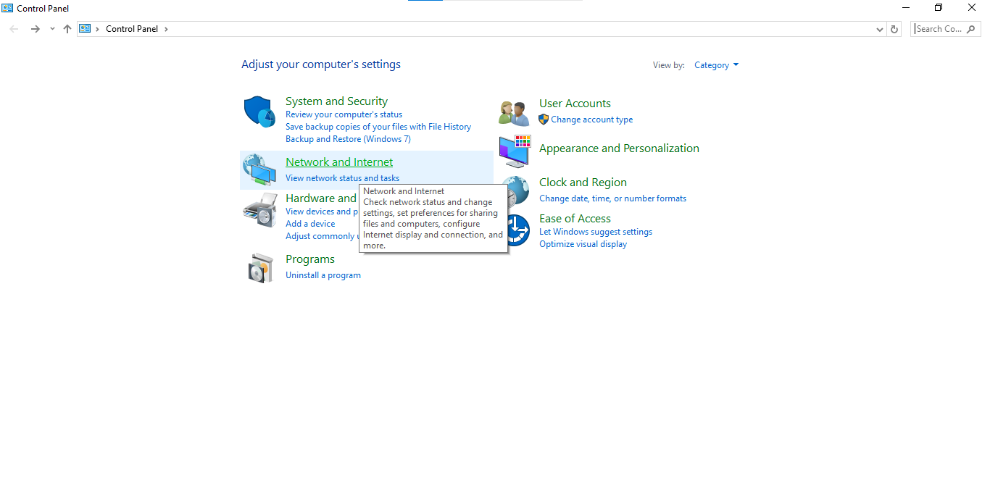

Step 3: Select the Network and Sharing Center.

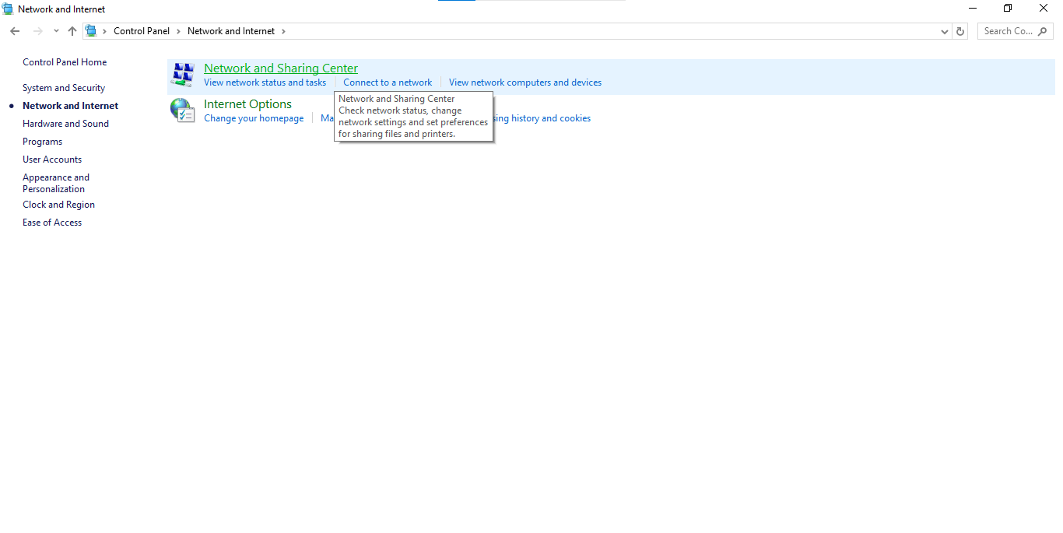

Step 4: Click the Wi-Fi connection
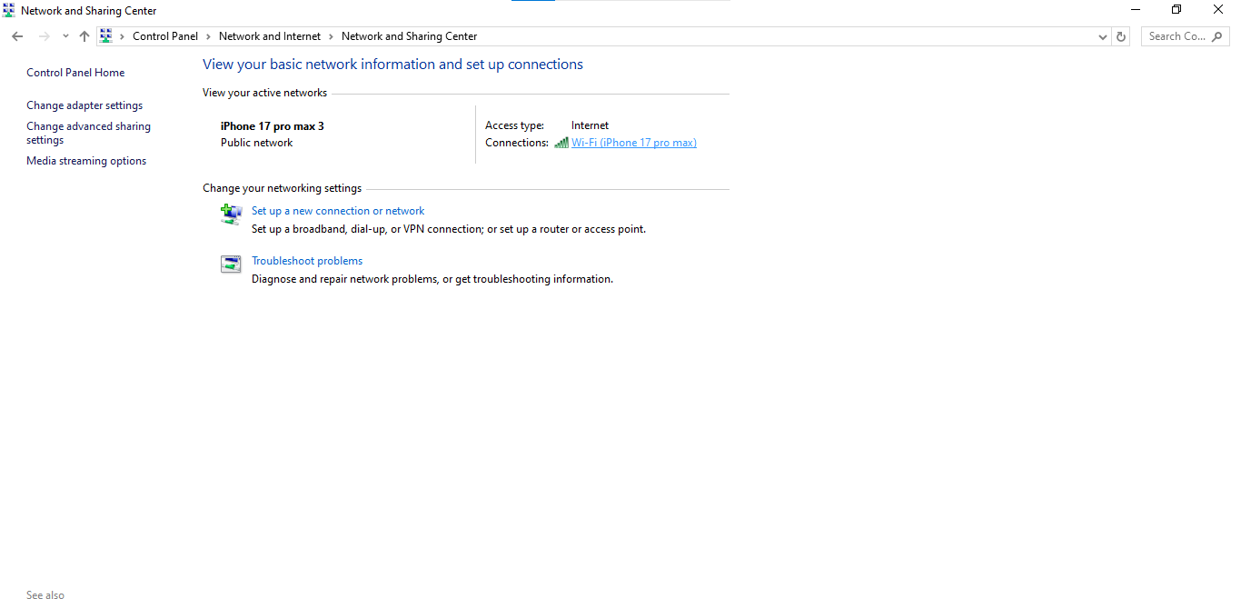

Step 5: Click on Properties

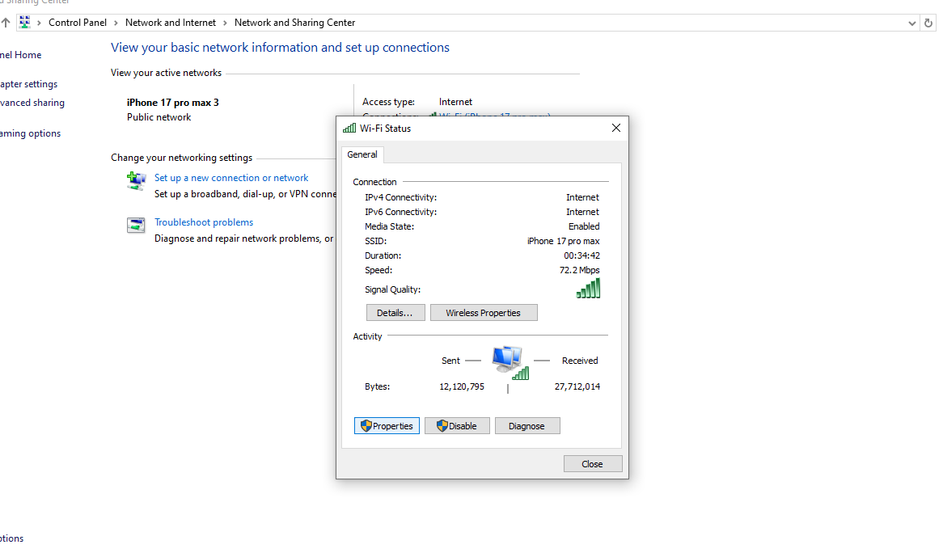

Step 6: Select the ICP/IPv4 and the Properties.

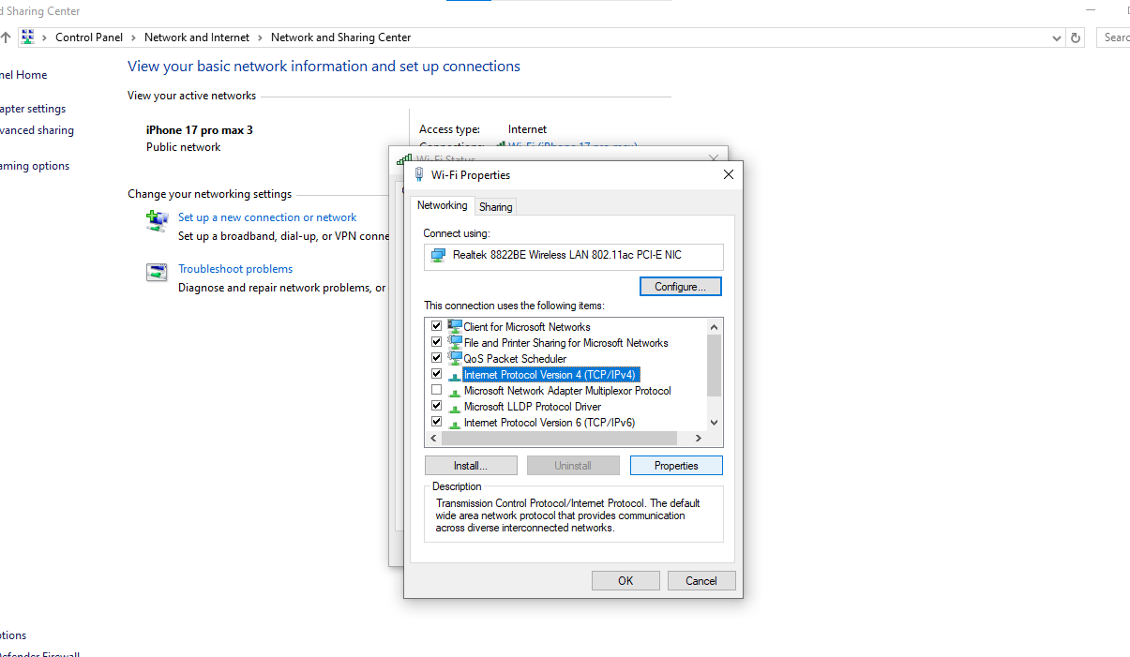

Step 7: Select the Advanced
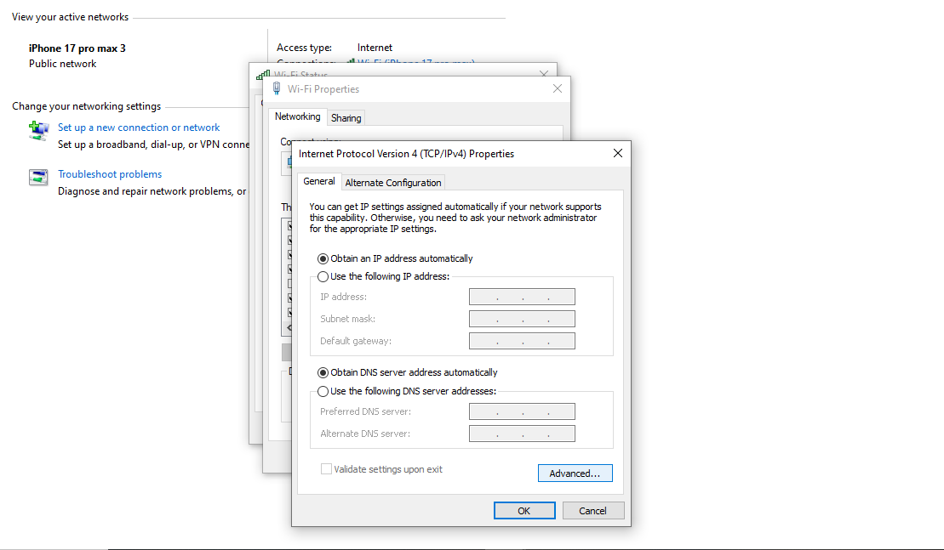

Step 8:Now click the WINS above and click the Add then, type the exact WINS IP address.

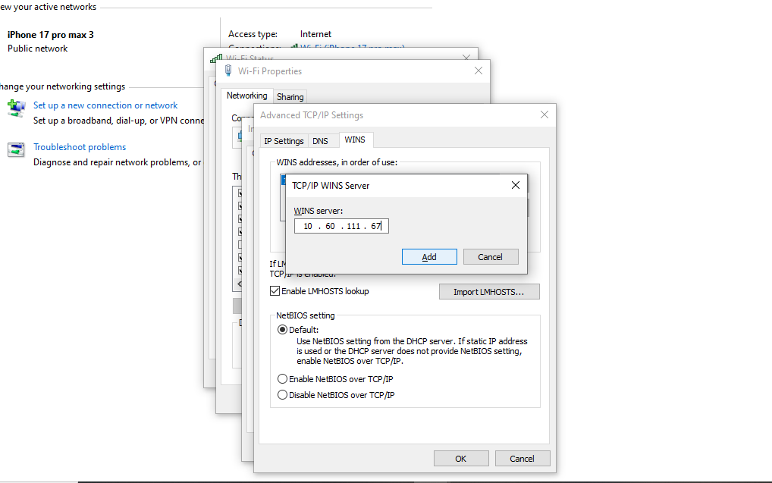

B. DHCP CONFIGURATION (CLI)
Command Prompt

Step 1: On the task bar, search the Command Prompt and click the Run administrator
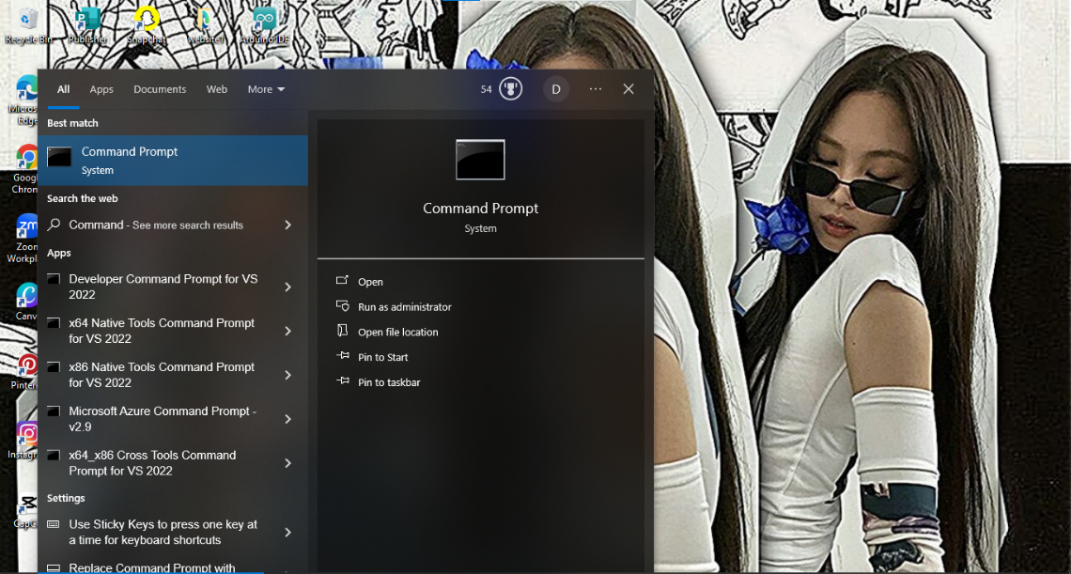

Step 2: Type the command:
netsh interface ip set address name=”Wi-Fi” dhcp
(Enables DHCP)

Step3: Type the command:
netsh interface ip set dns name=”Wi-Fi” dhcp
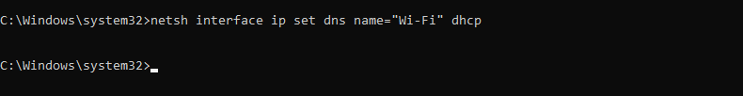

Network Summary

Devices | IPv4 Address | Subnet Mask | Default Gateway | DNS
2nd Floor
IT Room
PC1 | 10.60.112.2 | 255.255.255.0 | 10.60.111.67 | 8.8.4.4
PC2 | 10.60.112.3 | 255.255.255.0 | 10.60.111.67 | 8.8.4.4
PC3 | 10.60.112.4 | 255.255.255.0 | 10.60.111.67 | 8.8.4.4
Office Room
PC4 | 10.60.112.5 | 255.255.255.0 | 10.60.111.67 | 8.8.4.4
Work Room
PC5 | 10.60.112.255 | 255.255.255.0 | 10.60.111.67 | 8.8.4.4
PC6 | 10.60.112.256 | 255.255.255.0 | 10.60.111.67 | 8.8.4.4
PC7 | 10.60.112.257 | 255.255.255.0 | 10.60.111.67 | 8.8.4.4
PC8 | 10.60.112.258 | 255.255.255.0 | 10.60.111.67 | 8.8.4.4
PC9 | 10.60.112.259 | 255.255.255.0 | 10.60.111.67 | 8.8.4.4
PC10 | 10.60.112.260 | 255.255.255.0 | 10.60.111.67 | 8.8.4.4
PC11 | 10.60.112.261 | 255.255.255.0 | 10.60.111.67 | 8.8.4.4
PC12 | 10.60.112.262 | 255.255.255.0 | 10.60.111.67 | 8.8.4.4
PC13 | 10.60.112.263 | 255.255.255.0 | 10.60.111.67 | 8.8.4.4
PC14 | 10.60.112.264 | 255.255.255.0 | 10.60.111.67 | 8.8.4.4
PC15 | 10.60.112.265 | 255.255.255.0 | 10.60.111.67 | 8.8.4.4
PC16 | 10.60.112.266 | 255.255.255.0 | 10.60.111.67 | 8.8.4.4
PC17 | 10.60.112.267 | 255.255.255.0 | 10.60.111.67 | 8.8.4.4
PC18 | 10.60.112.268 | 255.255.255.0 | 10.60.111.67 | 8.8.4.4
PC19 | 10.60.112.269 | 255.255.255.0 | 10.60.111.67 | 8.8.4.4
PC20 | 10.60.112.270 | 255.255.255.0 | 10.60.111.67 | 8.8.4.4
3rd Floor
Maintenance Room
PC21 | 10.60.113.6 | 255.255.255.0 | 10.60.111.67 | 8.8.4.4
PC22 | 10.60.113.7 | 255.255.255.0 | 10.60.111.67 | 8.8.4.4
Work Room
PC 23 | 10.60.113.255 | 255.255.255.0 | 10.60.111.67 | 8.8.4.4
PC 24 | 10.60.113.256 | 255.255.255.0 | 10.60.111.67 | 8.8.4.4
PC 25 | 10.60.113.257 | 255.255.255.0 | 10.60.111.67 | 8.8.4.4
PC 26 | 10.60.113.258 | 255.255.255.0 | 10.60.111.67 | 8.8.4.4
PC 27 | 10.60.113.259 | 255.255.255.0 | 10.60.111.67 | 8.8.4.4
PC 28 | 10.60.113.260 | 255.255.255.0 | 10.60.111.67 | 8.8.4.4
PC 29 | 10.60.113.261 | 255.255.255.0 | 10.60.111.67 | 8.8.4.4
PC 30 | 10.60.113.262 | 255.255.255.0 | 10.60.111.67 | 8.8.4.4
PC 31 | 10.60.113.263 | 255.255.255.0 | 10.60.111.67 | 8.8.4.4
PC 32 | 10.60.113.264 | 255.255.255.0 | 10.60.111.67 | 8.8.4.4
PC 33 | 10.60.113.265 | 255.255.255.0 | 10.60.111.67 | 8.8.4.4
PC 33 | 10.60.113.266 | 255.255.255.0 | 10.60.111.67 | 8.8.4.4
PC 34 | 10.60.113.267 | 255.255.255.0 | 10.60.111.67 | 8.8.4.4
PC 35 | 10.60.113.268 | 255.255.255.0 | 10.60.111.67 | 8.8.4.4
PC 36 | 10.60.113.269 | 255.255.255.0 | 10.60.111.67 | 8.8.4.4
PC 37 | 10.60.113.270 | 255.255.255.0 | 10.60.111.67 | 8.8.4.4
PC38 | 10.60.113.271 | 255.255.255.0 | 10.60.111.67 | 8.8.4.4

CHAPTER V: CENTRAL MONITORING CONSIDDERATION

5.0 DIAGRAM

